Lab report

After download and install Power Bi Desktop and SQL server management studio I additionally install SQk server, because we need to work with recover DB “Adventure Works…”
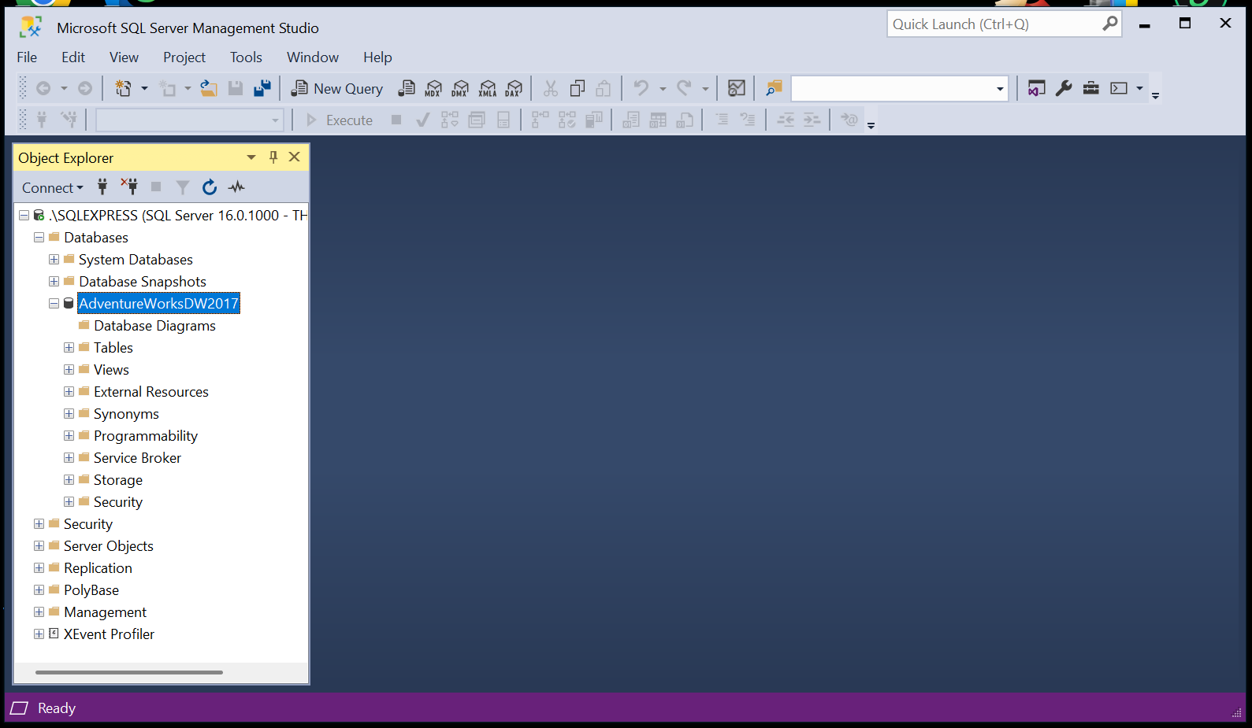

Next I download from this server DB table FactInternetSales table and Related Tables in PowerBI.
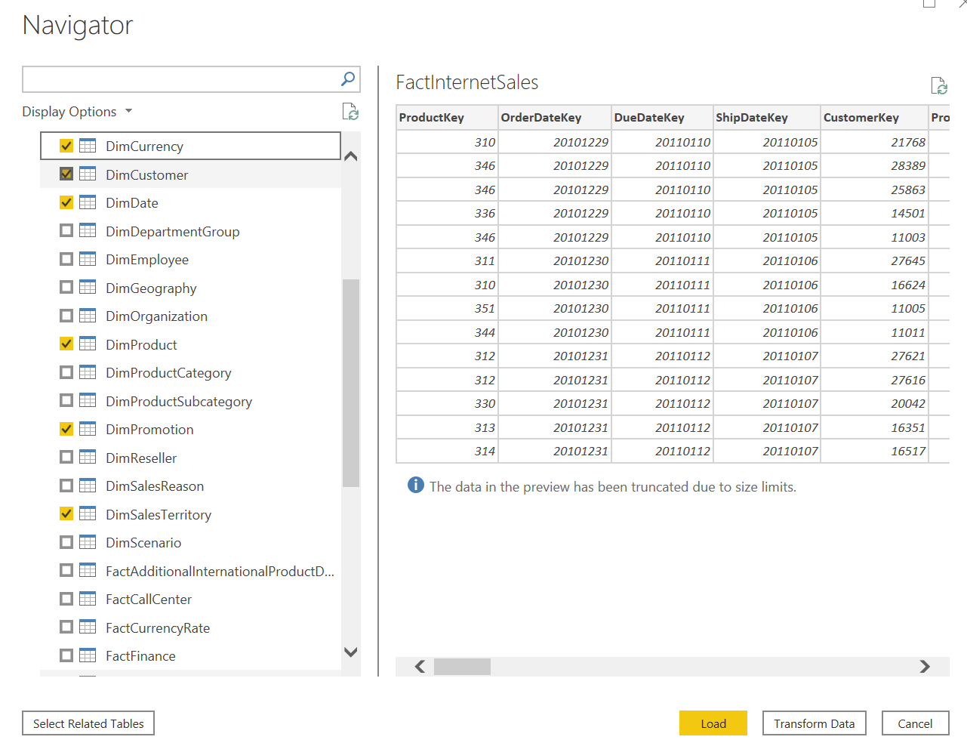
So I see Power query Editor window
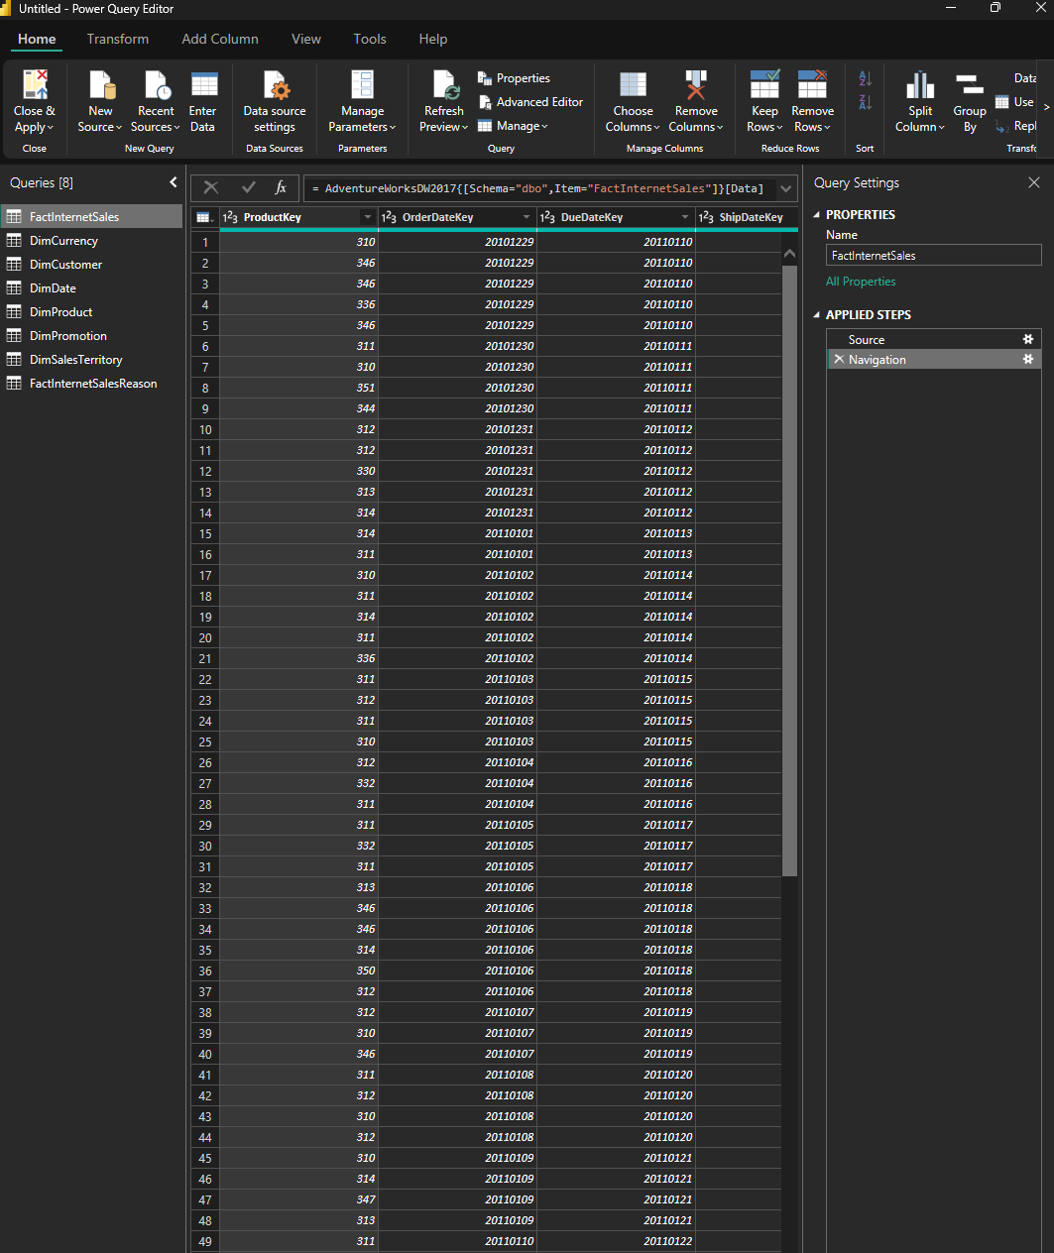

Then I need transform data:
Create a column with full Customer name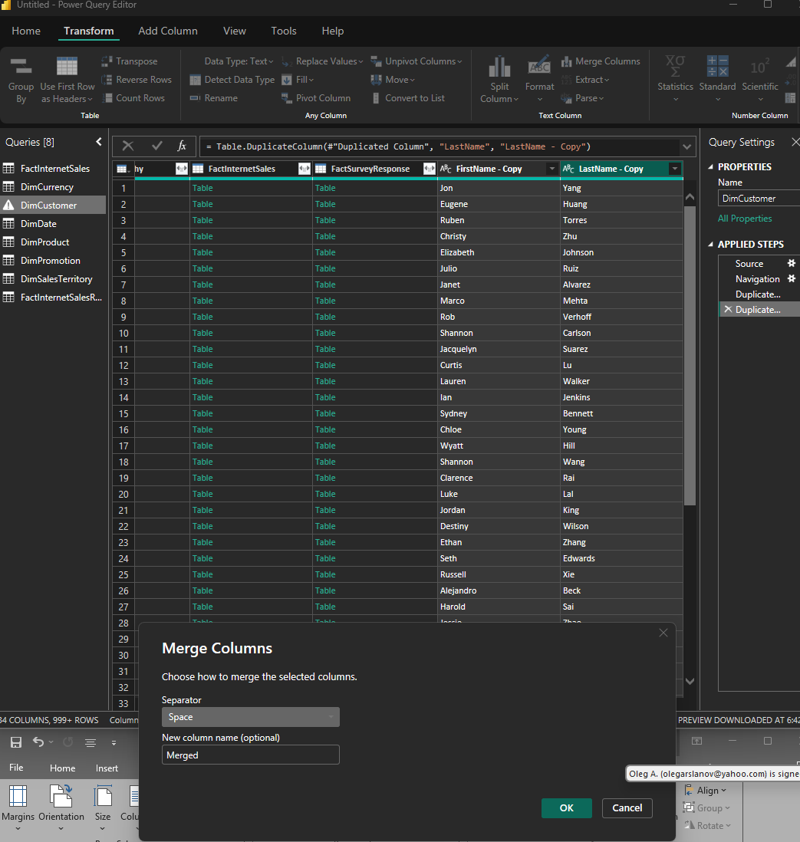

Change column name to Full Name
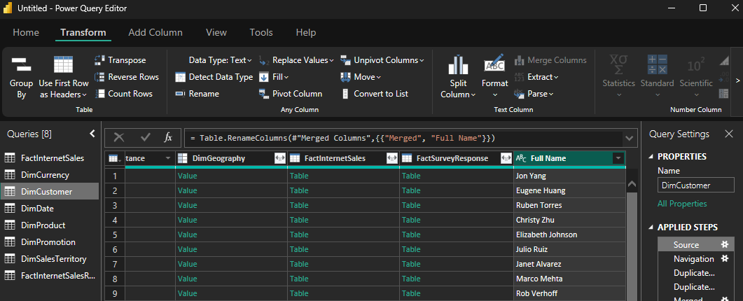

Change column type to %
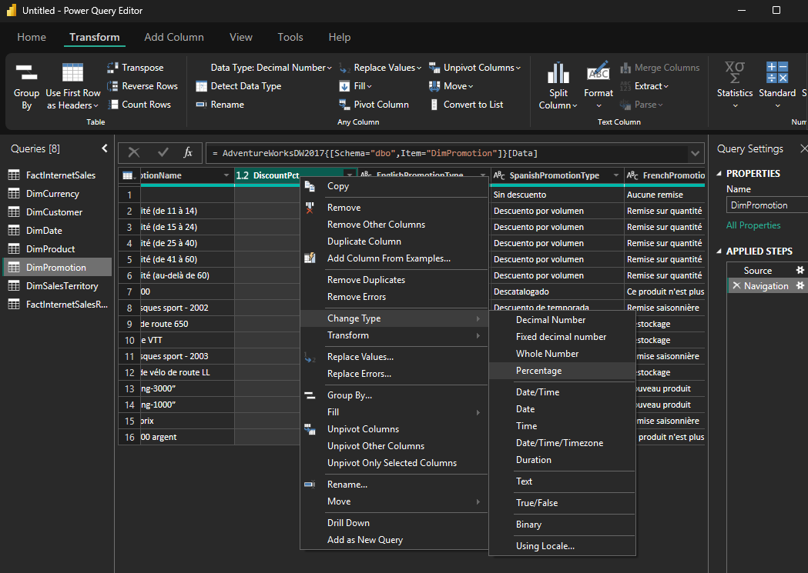

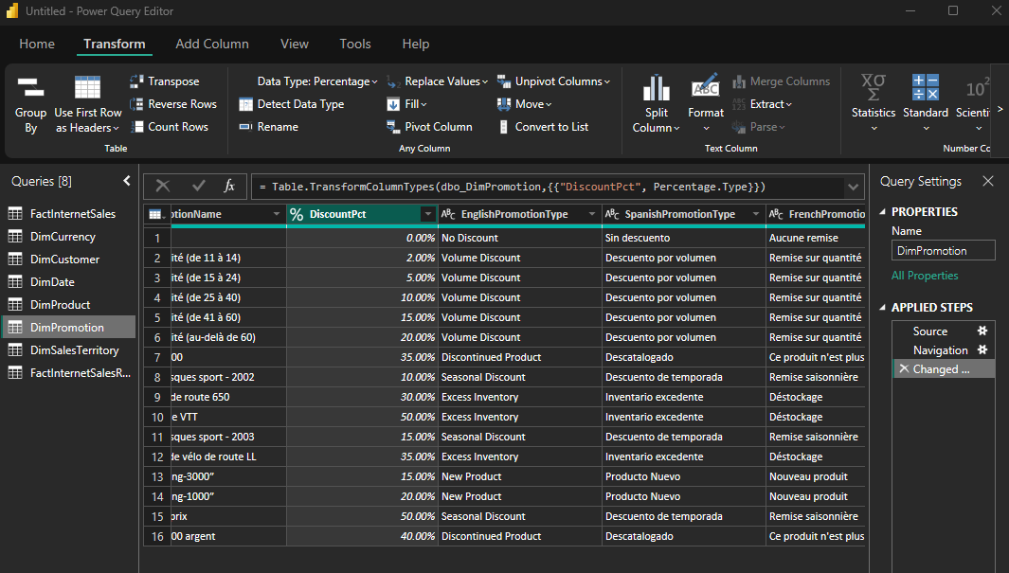

Calculate the length of Promo campaign.

Option #1

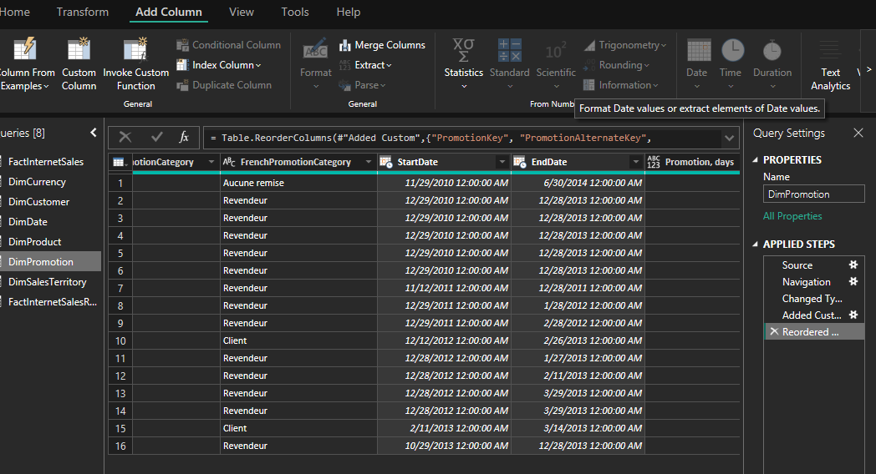
I don’t know I choose both colums, but not acive button Date (inside it can be choosen subtract days) … but this buttons don’t active

Option #2

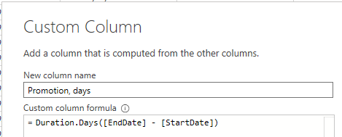

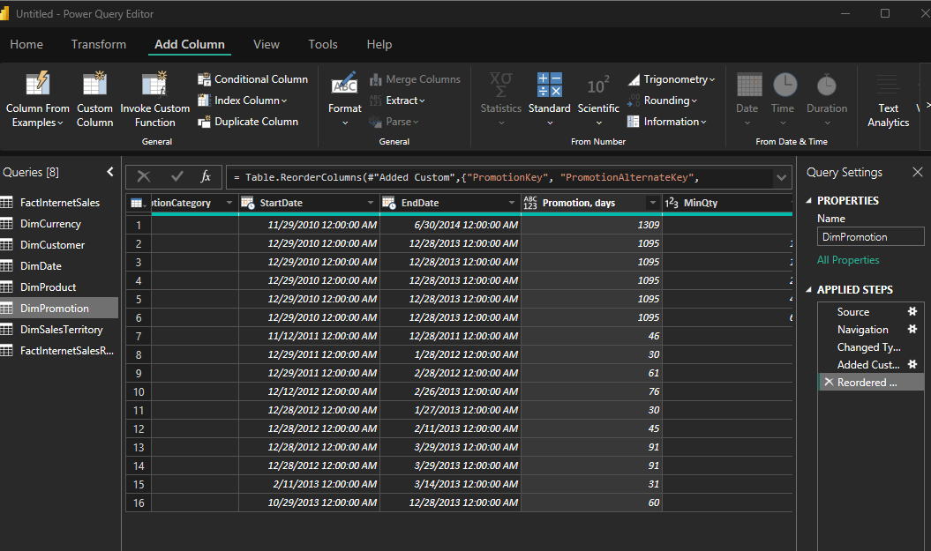

Adding new tables
Load additionally ‘DimProductSubcategory’ and ‘DimProductCategory’ tables from AdventureWorks

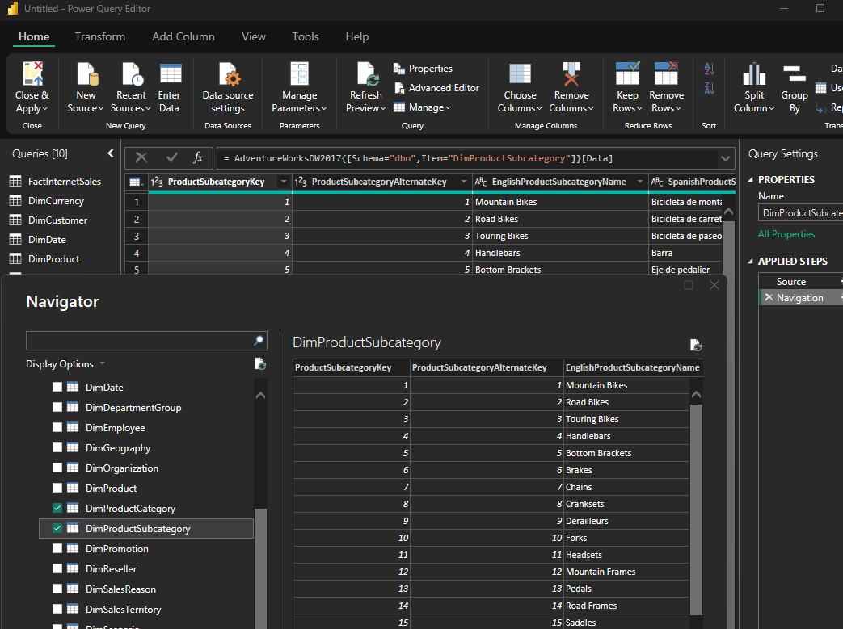

Data profiling
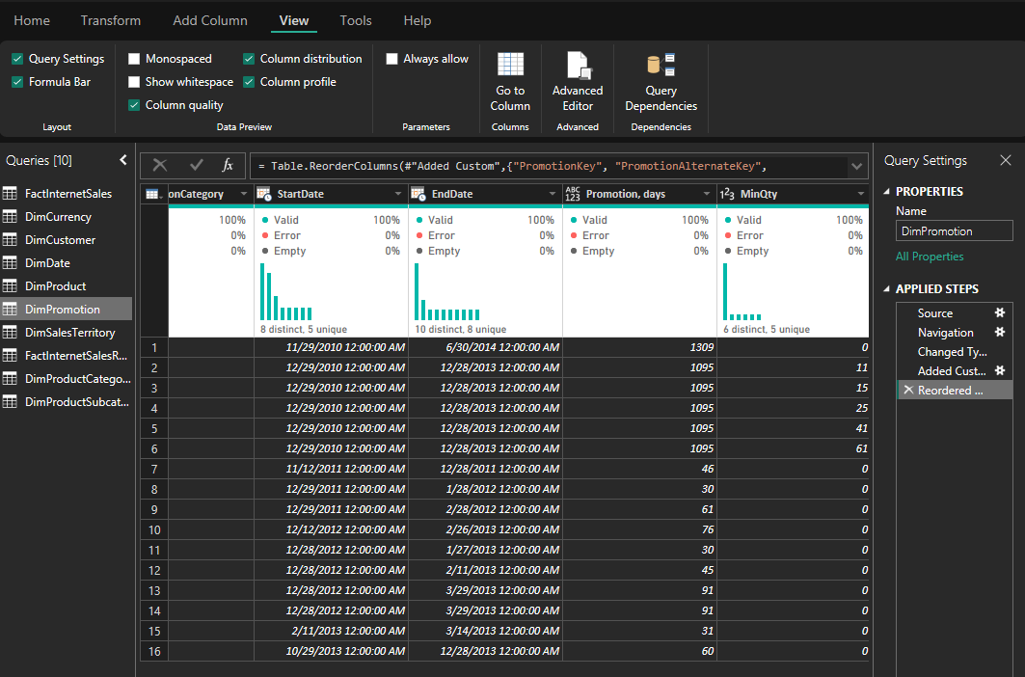

Create column Order Year from OrderDate column

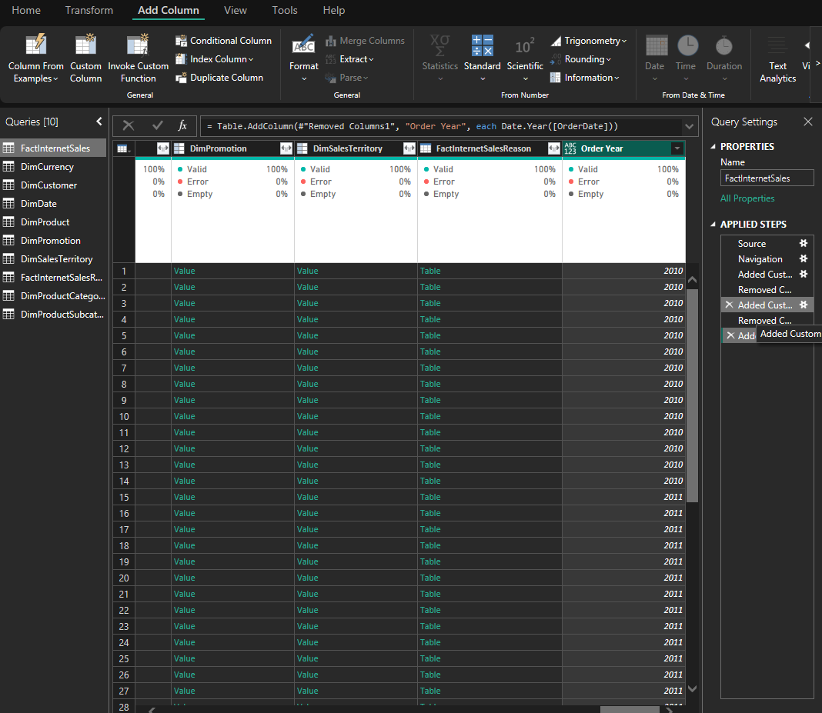

Pivot column
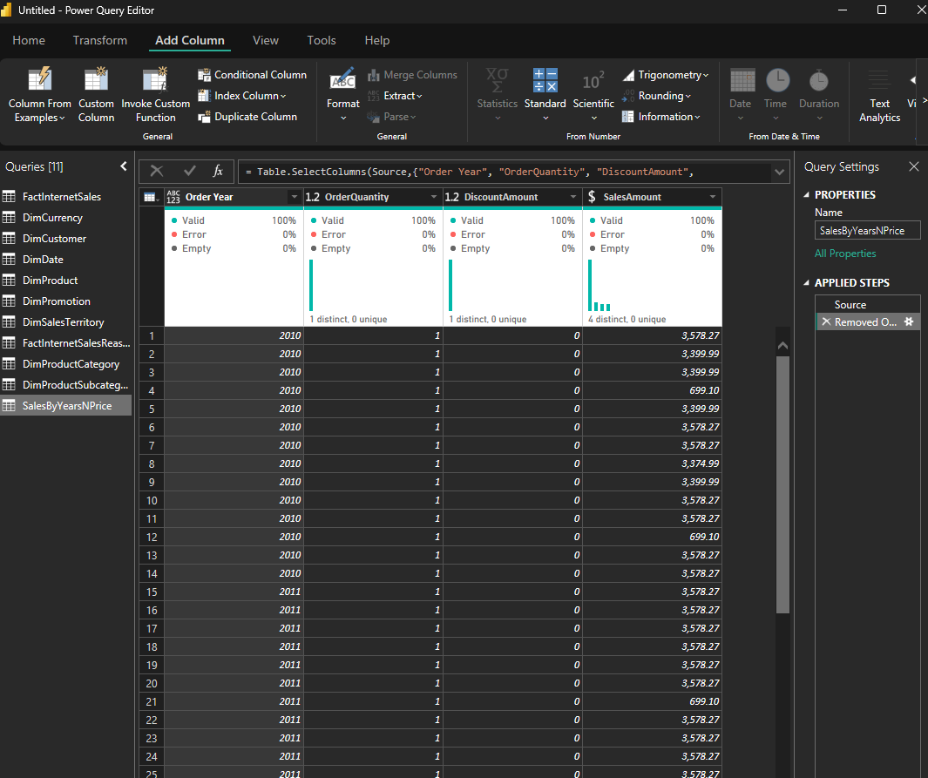

Pivot table by year summing by SalesAmounts
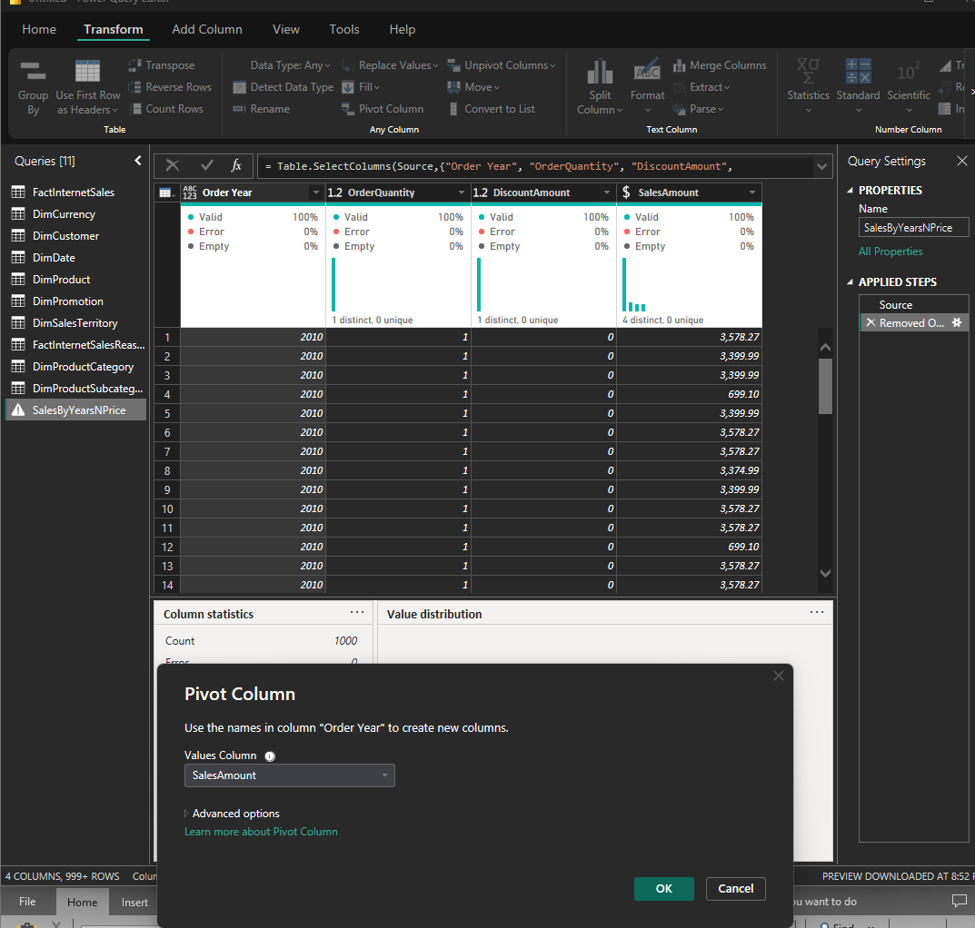
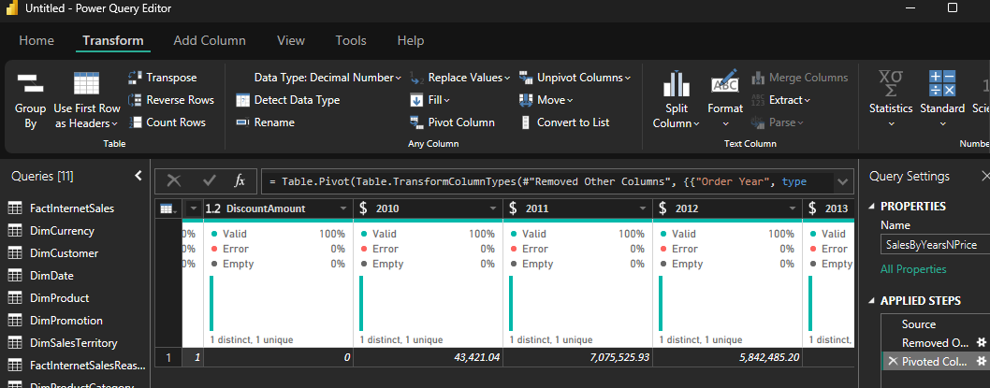

Table joining

- Join SalesByCountry and DimSalesTerritory
Key: SalesTerritoryKey
Purpose: Add the SalesTerritoryCountry column from DimSalesTerritory to SalesByCountry.

- Join the result with DimProductCategory
Key: ProductCategoryKey
Purpose: Add the EnglishProductCategory column from DimProductCategory to the merged table.

Steps:
Use Left Outer Join for both merges.
Expand the joined columns to include SalesTerritoryCountry and EnglishProductCategory.

Result
The final table will have:
Data from SalesByCountry
SalesTerritoryCountry from DimSalesTerritory
EnglishProductCategory from DimProductCategory

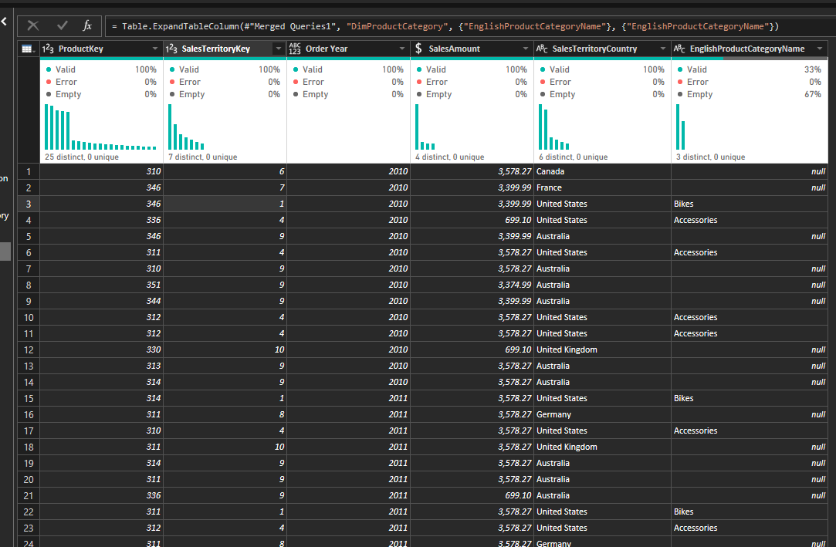

Grouping data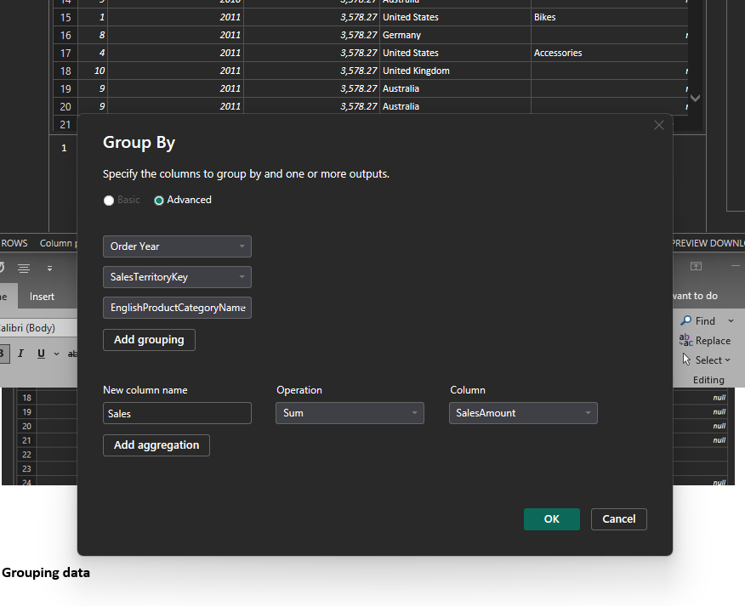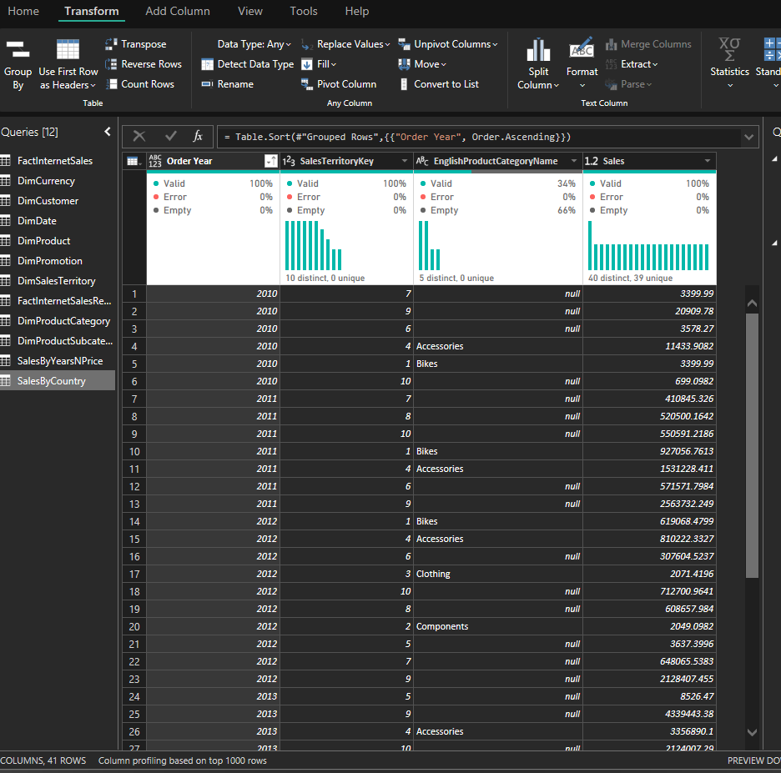

IMPORT VS DIRECT QUERY
1. Import Mode
Data is loaded into Power BI. All data is stored in the .pbix file.
Pros:
Fast performance (data is already loaded).
Full Power BI features available (e.g., calculated columns, complex transformations).
Cons:
Limited data size (usually up to 1 GB).
Data needs to be refreshed manually or on a schedule.
Use Import for small datasets and fast reports.

2. Direct Query Mode
Data stays in the source (e.g., SQL Server). Power BI sends queries to the source every time you interact with the report.
Pros:
No data size limit (great for large datasets).
Real-time data (always up-to-date).
Cons:
Slower performance (queries are sent to the source).
Limited Power BI features (e.g., no complex transformations in Power Query).
Use Direct Query for large datasets or when you need real-time data.

Example
Import: Like downloading a movie to watch offline. Fast, but takes up space.
Direct Query: Like streaming a movie. Always up-to-date, but needs a good internet connection.

WORKING WITH POWER BI MODEL

Tables FactInternetSales and DimDate left only one relationship by key OrderDataKey = DataKey. This is needed for analyze by order date (another relationships can make filtration and visualisation problems …)

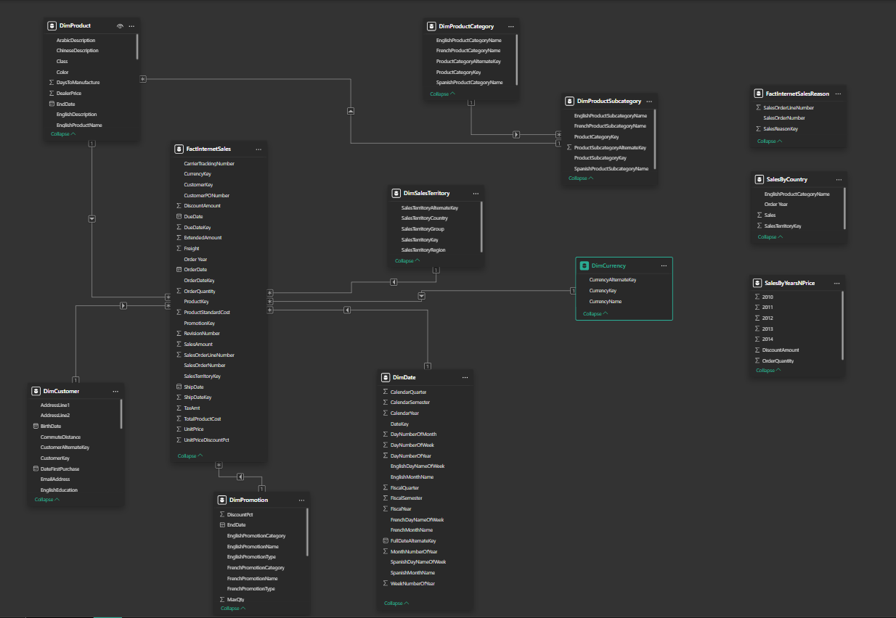
1. Cardinality
Defines how tables are related (e.g., one-to-many, many-to-many).
Example: One category (Table A) can have many products (Table B).
2. Cross Filter Direction
Determines how filters flow between tables (e.g., one-way or two-way).
Example: Filters from a date table (Table A) apply to sales data (Table B).
3. Active/Inactive Relationships
Active: Used by default for filtering (bold line). Can be only one
Inactive: Not used by default but can be used in DAX (dashed line). Can be many
Example: Only one relationship (e.g., OrderDate) is active between tables.

